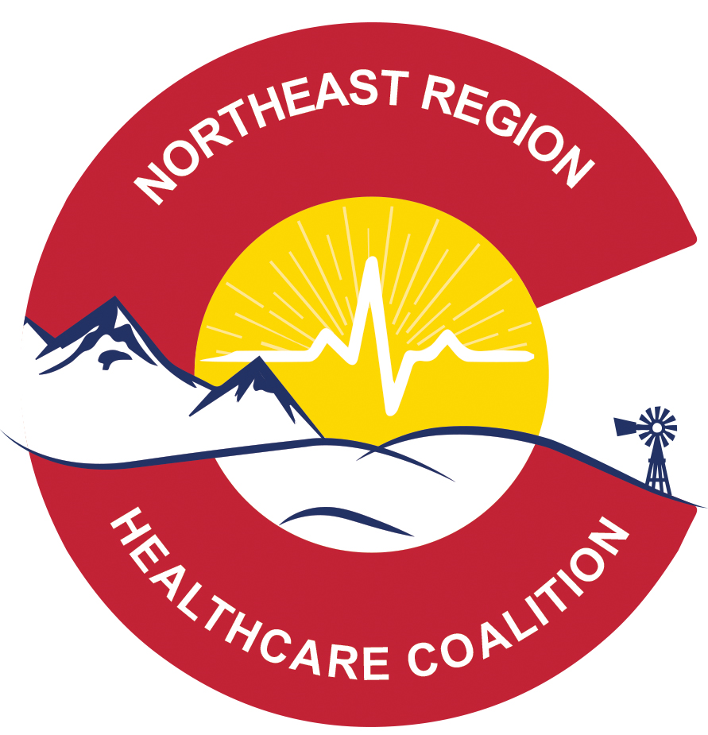
nORTHEAST REGIONAL HEALTH CARE COALITION

MEETING AGENDA: wednesday October 23rd 2019

MEETING LOCATION: Morgan Community College, 920 Barlow Rd, Ft Morgan 80701
MEETING TIME: 10 a.m. Meeting called to order: 10:08am
ZOOM MEETING LINK: Please, register in advance for this meeting:
https://zoom.us/meeting/register/7851b8d4882329d7cde7dc3c8da9331e
After registering, you will receive a confirmation email containing information about joining the meeting.

PRESENTATION OF THE AGENDA AND MINUTES FOR APPROVAL- Any additional business?
Deanna motioned, Dustin seconded, Board approved

INTRODUCTIONS:
In Person Attendees:

Erin Witte – Wray Hospital
Deanna Herbert – Weld DPHE
Darcy Jansson – Kit Carson DPHE
Bryant McCall – Washington OEM
Jerry Casebolt – Logan OEM
Dustin Handley- UCHealth Greeley Hospital
Shannon Wicker – UCHealth EMS
Mike Burnett – Northeast CO HD
Kristi Brock– Northeast CO HD
Jason Eisenbach _ Larimer DPHE
Jennifer Chase – Larimer DPHE
Matt Bauer – Weld DPHE
Mikey Brown – Haxtun Hospital
Dave Crowley – Good Samaritan Bonell
Travis Groth – Eben Ezer Lutheran Care
Tony Hanlon – Rehab/Nursing Ctr of Rockies
Kevin Kuretich – DHSEM
Caitlin Langmead -NERHCC
Jamie Brecht – Centennial Mental Health
Sharon Greenman – Centennial Mental Health
Bob Heldenbrand – Phillips OEM
Rob Crowder- Sedgwick OEM
Roger Doll – Morgan OEM
Kari Serl – Washington County NH
Brenda Rhea – Washington County NH
Omar Gutierrez – Sunrise Clinic
Denise Bradshaw – Weld OEM

Remote Attendees: To be read out during introductions

Ken Stroud – Lincoln OEM
Jasmine Shea – Keefe Memorial Hospital
Ashley Williams – Columbine Health Systems
Merrie Garner – Carbon Valley EM
Kelli Adamson – Cheyenne DPHE
Andrew Kamei – UCHealth EM
Linda Thorpe – East Morgan County Hospital
Glenn Griffin – Colorado Plains Medical Center
Valerie Boyd – Kit Carson County PH
Carolyn Elliot – CDPHE

OLD BUSINESS:
- Fiscal Report - Ron Seedorf (not in attendance)
- Deliverable Updates – Caitlin Langmead
  - Elements of Essential Information/Resource Assessments
  - Membership List
  - Hazard Vulnerability Assessment – CDPHE Tool – research pending.
  - Capability Assessment
  - TEPW
NEW BUSINESS:
- Nomination of Urban Representatives – Erin motioned, Dustin second, board passed
  - Shannon Wicker (EMS)
- Psychological First Aid – Sharon Greenman
  - North Range is helping to provide trainers, Logan county asked to host, Weld possibly
- Print Licenses - Erin Witte and Caitlin Langmead
  - 19 Licenses, Board will work on documentation needed prior to distribution.
  - Ask about TrackApp licenses when surveying for print licenses
  - Board is seeking Interest in housing 3 credentialing computers around region
- RapidTag Use Form – Caitlin Langmead
  - Feedback will be applied to update the form
  - Upon finalizing form, members are asked to use it going forward, as well as to do their best to complete a form for events held in the past, to ensure more data is captured
- Regional Radio for Coordinator
  - Mike Burnett will provide Caitlin with a radio from his supply.

- Sector Updates:
  - Emergency Management
    - Cybersecurity training, December 16th 10a-2p, in Sterling
    - AFN Training - Nov. 5th Colorado Springs, Nov. 7th Montrose
      - Virtual option!! Please use the link below to register for the virtual attendance. With this registration, you will get the link to both the Tuesday November 5th and Thursday 7th.
Register here for virtual option: https://www.eventbrite.com/e/virtual-attendees-getting-it-right-access-functional-needs-conferences-registration-76152663667
https://www.colorado.gov/pacific/dhsem/news/2019-colorado-getting-it-right-emergency-management-access-functional-needs-conference
    - Follow-up: Phillips County Corn Fest 9/28, Rapid Tag use for volunteers went well overall
    - WebEOC update by Kevin Kuretich, 213RR information
    - WebEOC and ReadyOp notification groups, contact Kevin for help

  - Public Health
    - Hep A: Since last Oct, population experiencing homelessness, substance users and incarcerated, 223 cases, 70% hospitalized, 2 deaths, 13 counties affected. Outreach is ongoing at shelters and jails, among others.
    - Flu/Norovirus/RSV - respiratory illness information from state. Please, report suspected cases to Public Health, no negative repercussions will occur as a result of reporting, but it greatly aids public health in their work.
    - POD Exercises: Kit Carson 10/7 Drive-thru – able to track throughput during POD, as well as payment, adult vs minor counts and staff costs
Lincoln 10/9 Drive-thru – No rapidtag used
Cheyenne 10/12 Facility – No rapidtag used

  - EMS
    - UCHealth expanding in region, implementing a community paramedic program
    - Help to take burden off of 911 calls from repeat patients
    - Ultrasounds, x-rays, labs, mental health outreach, resource referral
  - Hospital
    - High census in Weld, all types of patients, some confirmed flu
    - Wray Hospital Active Shooter Drill – simulated four shot, two dead, lockout in less than 2 minutes. Borrowed Bob Heldenbrand’s TrackApp, 52 members of staff evacuated and reunified successfully.

  - Other (Long Term Care, BH, etc.)
    - Centennial Mental Health – working with Melissa Memorial, integrated care physician – helping with assessments, referrals
    - CMH and Sterling Regional Med Center – 1 physician embedded
PRESENTATIONS: Audrey Goold – Coalition Survey Results

OTHER BUSINESS: Conversation about radios to be added to agenda for next meeting

ACTION ITEMS: Caitlin to send out Governance document per request from Sharon Greenman

ADJOURN: 2pm, following TEPW

