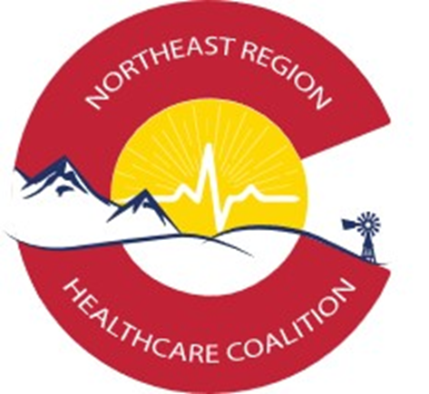

Inclusion of Volunteers in

Medical Surge

Northeast Regional Healthcare Coalition Report
2019 Deliverable #14

Table of Contents
1. Report Summary and Background 3
2. Volunteer Usage 3
2.1 Successes and Current Usage Examples 3
2.2 Challenges and Identified Gaps 3
3. Future Recommendations and Initiatives 3

1. Report Summary and Background
This report on the use and inclusion of volunteers in medical surge incidents is being provided to the Colorado Department of Public Health and Environment as a 2019 Healthcare Coalition Workplan, deliverable #14. Northeast Regional Healthcare Coalition members were surveyed on their use of volunteers to provide information on the current utilization and functionality of volunteers during surge response. Due to the pandemic response to COVID-19, the actual utilization of volunteer resources to respond to the surge event was able to be accurately measured with information gathering during the NERHCC After Action process.
Overall findings indicate NERHCC members do not currently utilize volunteers in response to surge incidents on a routine basis. The identification, on boarding, training, engagement, and management of volunteers for use in surge incidents seem to be main challenges to the effective usage of volunteers. Some hospital systems use volunteers effectively on a day to day basis, but those resources are not medically trained and would have limited scope or capabilities during surge incidents. Medically trained volunteers must maintain certifications, must be trained on hospital or entity policies and procedures, and are normally maintained locally as opposed to at the regional coalition level. Other volunteers able to provide time and support operations must also remain engaged to ensure they are ready to respond when needed.

2. Surge Volunteer Usage

2.1 Successes and Current Usage Examples
Based on the NERHCC AAR survey respondents, 11% of current NERHCC members utilized volunteers during the response to the COVID 19 pandemic which led to a community surge of patients. Of those reporting the use of volunteers, the following comments were shared directly about their use:
- We normally use volunteers for our agency, so they were used in response.
- We used volunteers but cannot specify specific usage for this report.
- Salvation Army and Team Rubicon were used for essential deliveries to the community – Their response was managed by the City EOC and were used after the local transit plan was modified. United Way was used for the Cold Weather Homeless Shelter (monitored by the IST), Salvation Army was used for feeding operations at the City’s Personnel Isolation Facility (PIF) – These efforts were managed by the City EOC.
- Volunteer Board members were used to fill in the gaps on the information and provide briefings centrally to maintain situational awareness in the community.
Many jurisdictions do not maintain volunteer databases on a routine basis but were able to effectively engage the community in the response efforts and identified people available to volunteer within their communities. These volunteers were trained using Just-in-Time training. Volunteers were used at community testing sites, within shelter locations and in Emergency Operations Centers during response. Although none of these examples tie directly to Surge response, this incident encompassed a surge of patients within the community and can be considered correlated response.

2.2 Challenges and Identified Gaps
Based on the NERHCC AAR survey respondents, 89% of current NERHCC members did not utilize volunteers during the response to the COVID 19 pandemic which led to a community surge of patients.
Common challenges reported regarding the use of volunteers include:
- Difficult to identify trained volunteers.
- Difficult to use healthcare trained staff outside of the hospital or health agency due to many limiting factors including:
  - Access, credentialing and understanding of internal systems and processes
  - Appropriate training
  - Identified scope of practice guidance for external partners
  - Security access / building access issues
  - Clearance and background checks
- Difficult to credential and maintain certification on volunteers if it is not handled internally to an agency and checked regularly.
- Difficult to identify volunteers who will be available to respond during a surge incident with correct skill sets.
Medical Surge response was managed within each hospital and healthcare facility and was not routinely managed using volunteers. Because of liability, training, regulatory and certification requirements the use of medical volunteers in surge within these agencies would not normally occur.
Volunteers might be used in the community to support large community surge response setting but would normally be provided as part of a State or Federally managed team based on the difficulty and complexity of medical volunteer management. It is difficult to envision a way to manage the levels of skills, training, resources, and certifications locally to maintain a useable team of volunteers able to rapidly deploy to support a surge of patients. Typically surge incidents last hours or at most days, but do not typically extend over multiple days and therefore would make it difficult to allow time to bring in awaiting volunteers.

3. Future Recommendations and Initiatives
In larger communities within the NE Region it might be possible to maintain lists of volunteers, to form and utilize volunteer groups, and to increase overall response capacity. However, the challenges presented through the use and management of volunteers are great and are often the inhibiting factor when considering the use of volunteers, especially in response to surge incidents in the community requiring healthcare skills for response. If CDPHE could provide the management function for these groups, their use might be increased. It is also important to remember that the same people who volunteer during a surge incident are usually people who work full time jobs during emergencies and so the actual available volunteer workforce may be significantly less during incident response and should be a planning factor taken into consideration.
A Volunteer Management Annex will be a required deliverable for the 2020-2021 HCC deliverables. This plan will include information on the following items:
- Identify situations that would require supplemental staffing in hospitals and leverage existing hospitals and health system staff sharing agreements and resources, to include volunteers.
- Develop a rapid credentialing verification processes to facilitate emergency response
- Identify and address volunteer liability, licensure, workers compensation, scope of practice, and third-party reimbursement issues that may deter volunteer use
- Leverage existing programs (ESAR-VHP, MRC) to identify and staff health care – centric roles during acute care medical surge response training, drills, and exercises
- Determine how to integrate volunteers into exercises, drills, and training within the Volunteer Management Annex

In the NE Region, a process to share staff and coordinate them among HCC partner agencies may be a focus of work over the coming years outside of the plan annex. The volunteer management annex will be developed and updated on an ongoing basis and will also refer to the CDPHE volunteer management plan to ensure it directly coordinates with Statewide volunteer management and usage efforts.

