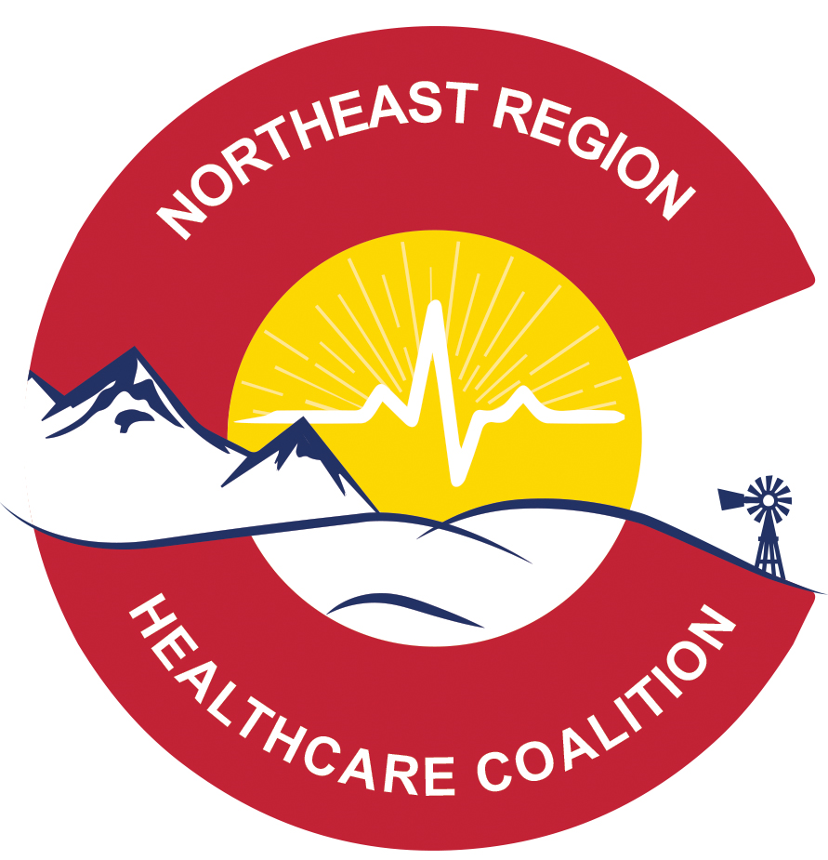
nORTHEAST REGIONAL HEALTH CARE COALITION

MEETING AGENDA: wednesday december 11th 2019 – VIRTUAL

MEETING LOCATION: VIRTUAL
MEETING TIME: 10 a.m. Meeting called to order: 10:09 am
ZOOM MEETING LINK: Please, register in advance for this meeting:
https://zoom.us/meeting/register/7851b8d4882329d7cde7dc3c8da9331e
After registering, you will receive a confirmation email containing information about joining the meeting.

PRESENTATION OF THE AGENDA AND MINUTES FOR APPROVAL- Any additional business?
Dustin motioned, Bryant second, no discussion, motion passed

INTRODUCTIONS:

Remote Attendees: Please, type your name and organization into the chat for the record.

Erin Witte – Wray Hospital
Caitlin Langmead - NERHCC
Dustin Handley – UCHealth Greeley
Bryant McCall – Washington OEM
Darcy Janssen – NER EPR
Ken Stroud – Lincoln OEM
Jennifer Chase – Larimer Public Health
Ashley Williams – Columbine Health Systems
Andrea Crowder – Haxtun Hospital
Eric Aakko – Weld Public Health
Thieta Stuart – Nathan – Surgery Center of FC
Karen Johnson – Suncrest Hospice
Kristi Brock – Northeast CO Health
Jeanine Shunk Bakke – Arete Surgical Center
Merrie Garner – Carbon Valley EMA
Ron Seedorf – Colorado Rural Health Center
Michal Brown – Haxtun Hospital
Paula Davis - CCHN
Glenn Griffin – Colorado Plains Medical Center
Kelli Adamson – Cheyenne Public Health
Maria Suarez – Tender Hearts Home Health
Sharon Greenman – Centennial Mental Health
Rob Crowder – Sedgwick OEM

ANNOUNCEMENTS:
Deanna Herbert’s resignation message

OLD BUSINESS:
- Fiscal Report - Ron Seedorf
  - Keefe Memorial Funding Project was mentioned, it has been on hold since the beginning of the fiscal year, outreach has been done by Caitlin. Darcy said she would follow-up.
- Deliverable Updates – Caitlin Langmead
  - Deliverables are due 12/31, will be reaching out for follow up information
  - Resource Assessments
    - Have received some from hospitals but it has been a struggle with most.
  - Hazard Vulnerability Assessment – Tool Access
    - Follow-up from October meeting regarding gaining access to the tool, Michael Delgado is still the admin, but will not grant access without those requesting watch a video about the tool and speak with him directly. Please, let Caitlin know if you would like access, so I can coordinate with Michael on a group call rather than multiple individual calls.
    - Regional HVA: Using data from the county HVAs, the HVA tool and previous HVA
- Open Record Conversation
  - Per a question about what the Coalition is required to share with the public, CDPHE has said that minutes and projects can be public on the website, but information such as data, or the specifics to deliverables may be behind a password protected wall for member access. However, anyone may request information as transparency is important overall.
- Radio Talk Group Reprogramming
  - In the November 7th Board meeting via Zoom, it was decided that the Coalition would not pay for or reimburse the costs of updating the radios to include the CDPHE talk group. This is for a variety of reasons, see the Board meeting notes on the website for specifics of that conversation.
NEW BUSINESS:
- Board Meeting on November 7th – Notes on website
- Salamander Work Group - Caitlin Langmead
  - A work group regarding Salamander use in the region was introduced. Such things the work group might cover would be peer to peer trainings, helping to find a contractor to assist with credentialing and created a strategic plan for the future usage of the system.
  - Those with interest should reach out to Caitlin.
- Salamander Update – Caitlin Langmead
  - In regards to Salamander it was discussed on the Board call that the Coalition has drifted from the initial intent of purchasing the equipment, which was to credential the region. The work group was suggested to help redirect that.
  - In light of the current situation with Salamander and the time that it has demanded, Caitlin expressed the need to step back from the project to focus on deliverables. While still willing to coordinate meetings for the work group, the work that needs to take place exceeds the amount of time she has to direct to the project. The Board understood this and this was part of the discussion to begin a work group.
- Funding Proposal – Caitlin Langmead
  - Funding proposal information will be sent out soon. Deadline of Friday, January 31st, with allocation decisions being made by Monday, March 2nd
  - Please, consider the emphasis from CDPHE on using funds for trainings and projects rather than equipment and “stuff” This will be taken into consideration when allocating funding.
- COOP (Continuity of Operations) Workshops – Caitlin Langmead
  - A proposal for COOP workshops was approved by the Board, which includes 6 workshops to be spread around the region.
  - This proposal was created from multiple requests during the TEPW about COOP training.
  - A regional COOP is a deliverable going forward in the next grant year and facilities having strong, pertinent COOPs would help to bolster this plan for the region.
  - COOPs are also listed in the CMS and JCO guidance, the question of whether or not they are a requirement was asked and while the review of the documents did not show requirement, it is strongly suggested and is listed multiple times in the guidance for both.
  - Asked whether or not a template exists online, Caitlin’s research showed there were various resources, but they did not take into account the multiple factors that a rural, critical access hospital would specifically need to consider. The goal of the workshops is to help but a more relevant and useful COOP for each hospital and their specific needs.
  - It was asked whether or not CDHPE/OEPR offers COOP training, it did not come up in the research prior to the proposal and the concern with utilizing state resources is the need to have multiple trainings around the region to make sure that travel is not excessive for members, that class sizes are reasonable and that everyone gets the same training with the ability to follow-up with their trainers, a specific option allotted within the proposal.
  - The question of whether or not a competitive bid procurement process (RFP) was used to hire this contractor was asked. Per an email (11/18/19) to our fiscal agent, Ron Seedorf, when asked about the process to procure a contractor, no mention of RFPs or the need for multiple quotes was expressed. Therefore, this proposal was created due to a recommendation of All Clear Emergency Management by another HCC Coordinator and a call was made to inquire about possible options.
  - Research is being done with CDPHE to verify if a specific process is needed since the funds are from a federal grant.
  - Overall, support was expressed for the concept of the workshops, the research will dictate whether or not more bids are needed or if we can move forward with the Board approved decision.

- Sector Updates:
  - Emergency Management – Merrie Garner with Carbon Valley EMA (Frederick, Firestone, Dacona – Weld County) is hosting a Disaster Finance course on January 8th
  - Public Health –
    - Jennifer Chase: Hep A: 299 cases , 2 deaths, 15 counties, Denver metro/Front Range, high hospitalization, 75% people experiencing homelessness, incarceration, drug use, men who have sex with men. Publicly funded vaccines, 18,500 administered, unknown for private funded, response ongoing since October. Hospital consortium met to discuss ED vaccines. UC Health Epic EMR module to help facilities to screen and order vaccines, Banner will also use module on Dec. 18th.
    - Educational materials for hospitals, social workers, infection preventionists – print materials for patients and around ED
    - Funding for vaccines is being allocated to prioritized counties, due to proximity to those experiencing cases

    - Darcy Janssen: More to come on critical workforce identification
  - EMS
  - Hospital
  - Other (Long Term Care, BH, etc.)
    - Psychological First Aid on January 30th in Haxtun
      - (Darcy offered to host another in her region)
PRESENTATIONS: None
OTHER BUSINESS: Next meeting date is January 22nd
Washington County Events Center
551. W 2nd St, Akron CO 80720

ACTION ITEMS:

ADJOURN: 11:20am

