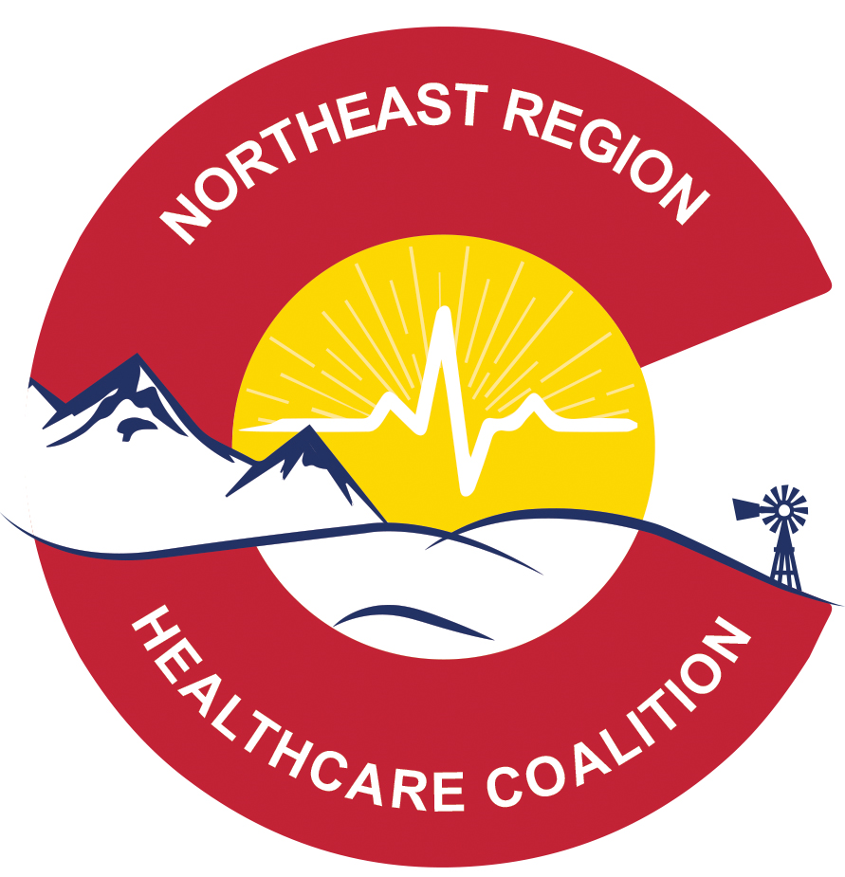
nORTHEAST REGIONAL HEALTH CARE COALITION

MEETING AGENDA: wednesday May 27th 2020 – VIRTUAL

MEETING LOCATION: VIRTUAL via ZOOM
MEETING TIME: 10 a.m.
ZOOM MEETING LINK: Please, register in advance for this meeting:
https://us02web.zoom.us/meeting/register/vJUqdeqopjkiaQnRvtRy1tx_wlDtJf4WGA
After registering, you will receive a confirmation email containing information about joining the meeting.

ATTENDANCE:

Andrea Crowder, Dustin Handley, Roger Doll, Darcy Janssen, Tracy Hayes, Travis Growth, Rob Crowder, Ken Stroud, Kari Serl, Roger Brown, Erin Witte, Nicole Cantrell, Ron Seedorf, Allen Geist, Dawn James, Kelly Slade, Andrew Kamei, Vickie Gillet

PRESENTATION OF THE AGENDA AND MINUTES FOR APPROVAL

ANNOUNCEMENTS: Registration will no longer be required for meetings ZOOM links will be shared directly

Move to approve meeting agenda – Andrea Crowder
Second Roger Brown -

OLD BUSINESS:
- Fiscal Report - Ron Seedorf
Report – All information is in the same format as usual – Approved projects not processed.
Keefe Memorial Hospital submitted an invoice for supplies and equipment ($2,519.14)
Sedgwick County OEM project complete
Haxtun Hospital approved project will still take place before June 30 it will be complete (trailer in hand - $5,994)
2 projects awaiting carry over approval past the end of June
CSU Health Network approved for 2 separate projects, 1 request for reimbursement has been received but it is less than was approved
2 contracts with Preparedness Partners, LLC
A Computer purchase was approved for Erin Witte as the

Remaining Funding for Survey deliverable payments - $
Information was received from Curt Drennan needs a budget completed by 10am tomorrow morning, Erin is working on that today for submission.

- HCC Coordinator Hiring Committee – Dustin Handley
Update – Dustin and Nicole spoke about the job description, some revisions were made and then we can share with the committee.
Conversations about direct or open recruitment, open to both but we are hoping to open it up broadly to find the best person for the job.

- Outstanding Deliverable Updates – Nicole Cantrell, interim HCC Coordinator
  - Pediatric Annex – Planning Meeting (June 2nd or 3rd)
  - Regional HCC Strategic Plan – Board Strategic planning session June 10th
  - Coalition Capability Assessment – Completed via survey
  - Use of Volunteers in Surge / Medical & Health Volunteers report – Completed via survey
  - HCC Mission Essential Functions – All Clear COOP workshops and via survey
  - Surge Estimator – Completed via survey
NEW BUSINESS:
- HCC Survey – Overview and Payment for Deliverables to HCC Partner Agencies
Discussion about CDPHE requiring Regional coalitions be “operational”. Lots of Coalitions oin Colorado are evaluating this and how it is actually working during response. The Survey feedback will help inform CDPHE on how things operate in the region, and what is working. The strategic plan will need to determine how to pull critical data from local groups, combine it and then get it distributed regionally. These are Essential Elements of Information (EEI). Hopefully the survey and strategizing will allow the coalition to move forward successfully while being a very useful group for everyone, not a duplication of efforts.
  - Survey was sent to all HCC partners on Tuesday May 26th. It will Close Date - Fri June 5th at 5 pm. No later survey responses will be accepted.
  - Survey answers will be aggregated by County
  - Agencies will be paid for completion of the entire survey which will inform Coalition deliverables and workplans. If questions are skipped you will not be eligible for a deliverable payment. Please provide lots of information, feedback and your thoughts so we can inform CDPHE, the draft strategic plan and the COVID regional AAR.
    - Upon completion of the survey for your agency, a current W-9 must be emailed to nerhc.co@gmail.com with the subject line: “Agency Name (exactly as you listed it in the survey)– Survey Deliverable Completion – W9 attached”
    - If you do not fully complete the survey, do not provide sufficient data in the survey, or do not email a current W-9 to the nerhc.co@gmail.com email, you will not meet the requirements for payment and no payment will be issued to your agency.
    - Anyone from an agency can complete the survey to provide input and feedback, and are encouraged to do so – but agencies will only be paid once*
  - The payment total will be determined by the total number of responding agencies (total of remaining funding divided by total eligible responses)
  - NERHCC Board Strategic Planning Meeting – June 10th will use survey feedback to discuss current state and what everyone desires from the Regional and local coalition groups.

- Sector Updates:
  - Emergency Management
Roger Brown – Yuma County is getting requests for PPE from various agencies, monitoring how planning is going, planning for potential future response. County adopted a variance in their plan, but City of Yuma didn’t do a variance, so the differences have been different. The City may agree to follow County guidance. Roger is forwarding information to various agencies to share what they are doing.

  - Public Health
Updates from Mike Burnett – Not a ton of updates that people aren’t aware of. Counties continue to maintain District Operations Center at full staffing (some remote) and incident management team is supporting activities. Investigation process is becoming more and more time consuming. A CDC Epi should be stationed at their County. Restructuring staff to draw in additional staff to support case investigation and working with counties on how to move forward with variances. Details are different county to county. Many questions are being referred back to County commissioners. Restaurant questions are also coming in and EH staff is working on clarifying information. EH staff is finalizing restaurant checklist to be compliant when they re-open. Statewide testing is a huge priority, there has been a lot of phone calls and confusion – Challenging to address Governor Polis’s comments that “Every Colorado can get tested if you want to” which was a challenge within communities. Not as much band width in smaller communities to support this. It will be interesting to see how a vaccine rolls out and how the State handles that.
Dawn – Kit Carson – got a variance for churches and restaurants (took 3 weeks) but there was anarchy in the streets, perpetuated somewhat by leadership, but glad to be able to have a variance. Been at 0% prevalence within the counties. 2 or 3 weeks out from last positive cases. Kit Carson has ID Now rapid testing and backing it up with CDPHE as needed, in the last week 80 swabs were completed. Capability to test is there but the interest is not there. This group could compile local perspective, PPE availability, hospital capacity, have some topics we capture and then share regionally (could be shared with the Boards) – Dawn suggested that NERHCC could gather local perspectives regarding county response, hospital capacity, other “Essential elements of information”
Darcy – Lincoln County will be doing a drive through test pod in Limon and Hugo – There are at least 200 or so test to be offered to anyone who wants to be tested. This will be in a drive through setting and be able to get a handle on what is happening within the County. This will help determine if they can move forward with any variance. Cheyenne County remains at 5 cases, most testing is happening at the hospital level.
Moving forward – Discussed previously that an NERHCC Coalition newsletter be put out monthly, but we need to determine what is captured and how or when it is distributed. Monthly or quarterly, maintain situational awareness and help support locals.
  - EMS – No reports
  - Hospital
Jasmine (Keefe Memorial) – Hospital is the only location in the County completing testing, also discussing antibody testing potentially being made available to the community. Hospital is working on that. Hospital has over 100 test kits available, but no mass testing is being discussed. Kits are also used for respiratory panels and flu, so they won’t be shared widely. Not many COVID specific kits have been received.
Andrea (Haxtun) – Doing serum antibody COVID testing through direct access testing. IT is $80 and you don’t need a physician order to complete it. PPE supplies are good. Visitors are being restricted in their care sites, which is getting difficult for residents. Hopefully this can change soon.
Erin (Wray hospital) – Have had a couple outbreaks, a few nurses went out yesterday and completing 180 swabs for testing. 24/48 turn around time on testing so expecting results by Friday or Saturday. This meant Yuma County totals had a jump last week, if more than 10 new cases in a 7-day period the variance will change. Currently they are at 9 cases in a 7 day period. This location hasn’t seen much so this is possibly changing. Hospital hasn’t seen patients internally yet, but there might be more to come. Hospital is preparing for this potential influx of patients.
Tracy Hayes (Banner) – Working on system wide data monitoring – Looking at the trending cycle now and they are seeing it slide down. But they are keeping eyes on prison in Sterling and anything else in East Morgan and looking at larger employers in the areas, watching for spikes. A new collection of data is “newly admitted over 24 hours for COVID positive/suspected” and this info is being shared with partners. Also working on After Action process from a system perspective, and working with multiple states to evaluate trends, processes, improvement plans and trends to make adjustments and plan for possible occurrence in the Fall. Another team is also evaluating testing capabilities within facilities.
Andrew – Surpassed peak in April 26 (100 patients) today there are 10 inpatients and a consistent decline. Testing has been expanded (1 testing site launched in Fort Collins) and now have 5 other locations in Northern Colorado. Public testing sites are available in Greeley, Longmont, Fort Collins and a new site being set up in Loveland. Most sites are open 7 days a week and open to the public, so this is an available resource. Testing will be ongoing for the indefinite future. Response is calming and getting back to more normal, Command Center is not operating but there are triggers for when it will need to be reactivated. Looking to the Fall for an uptick and possible reopening. Critical Care Staff knowledge is important so working through lessons learned and evaluating bed capacity and expansion region wide.
Vicky (Yuma District Hospital) – Drive through testing has been ongoing for several weeks 3-4 pm and this will be extended because it isn’t enough time to get people through. This time will be extended starting next week from 3-4:30. Had some positive COVID patients in the hospital, some have stayed inpatient and some have been transferred to other hospitals. Incident Command was stood up and a COVID steering and planning committee is tabled but they will begin looking to Fall. Meeting daily for COVID incident command, they are now meeting 1 a week to establish baseline. They are also sharing among counties what is going on and gathering situational awareness. City Council and County Commissioners are meeting and talking about two different sides of counties and totally different things are happening. County will decide what to do and how large testing initiative will impact plans as they sit currently “Safer at home” and variances.
Want to look at washing protocol and determine how long they can be reused and cleaned. Shorter style ties work much better when washing.
Mike – it is unlikely they will be getting any gowns from the State
  - Long Term Care / Skilled Nursing
Travis – Reporting that things are doing much better – PPE perspective and cases continue to drop and more people are moved off isolation. Almost 100 staffing and lots of work. Special shout out to local assistance and thanks so much for support from Mike and lots of partnering support.
Dawn – Grace Mannor has an outbreak of 22 cases, but no new incidents of COVID in 4 weeks. Progressing with opening to limited visitation for residents, nursing home submitted protocol to PH and going through Board of Health for approval today to start accepting new residents (they have been restricted) all new residents will need to be cleared with a negative test and will be required to quarantine for 14 days so this process is evolving and being approved now.
Kari – No new cases, working to obtain additional gowns. No other concerns.

  - Behavioral Health – No reports

PRESENTATIONS: None

OTHER BUSINESS: Level 3 alternate care site is being opened at The Ranch – initial occupation capacity at 80 beds, remained of the site is shelved for now. UCHealth is providing medical leadership and scheduled to go live with 80 beds on June 13th – Will only be activated if needed.
Denver Convention Center will go through initial process and go love next week. Most patients would go to Denver Convention Center first then possibly transferred. Surge and patient movement will be coordinated by State. As lessons are learned we will inform everyone.

ACTION ITEMS: Next Meeting - June 24th at 10am

ADJOURN: 11:25

