Northeast Region Healthcare Coalition Continuity of Operations (COOP) Workshop Series

Summary Report

Project Dates: January 23, 2020 – April 15, 2020
Report Date: April 15, 2020

Completed by:
All Clear Emergency Management Group
3434 Edwards Mill Road, Suite 112-162
Raleigh, NC 27612
336-802-1800

Project Lead:
Lauren Smith
Planning Specialist
LaurenS@AllClearEMG.com

Continuity of Operations (COOP) Workshop Series

Summary Report

All Clear Emergency Management Group
All Clear Emergency Management Group, LLC, is a planning and preparedness firm headquartered in Raleigh, NC. The company is led by business partners William Moorhead and Ginny Schwartzer. All Clear has been providing emergency management services for hospitals, public health, healthcare coalitions, schools and universities, government agencies, churches and religious organizations, and businesses since 2009.

For this project, Lauren Smith was the Project Manager, and Jenny Schmitz was the Project Staff.

Project Summary
The Northeast Region Healthcare Coalition (NERHCC) contracted with All Clear Emergency Management Group to develop and facilitate a Continuity of Operations (COOP) Workshop Series. All Clear worked with the NERHCC to develop a COOP introductory webinar and then facilitated in-person COOP development workshops to provide guidance on how to create and implement COOP plans within their individual facilities and/or agencies.

Project Activities and Deliverables
The All Clear team worked closely with the NERHCC Point of Contact to ensure all deliverables were met in a timely and satisfactory manner. The project activities and completed deliverables followed the proposal set forth by All Clear. Summaries of the project activities and deliverables are listed below:
- Phase One: Plan and Initiate
The official project kickoff meeting was held on December 20, 2019 with All Clear and the NERHCC. This meeting reviewed the Project Staffing, developed objectives for the COOP webinar and workshop series, and the Project Timeline. An additional project planning meeting was held on January 7, 2020.
  - Deliverables
    - Kickoff Meeting agenda and minutes
    - Project Planning Meeting agenda and minutes

- Phase Two: Design and Facilitate an Introductory COOP Webinar
All Clear developed and facilitated a COOP 101 introductory webinar that provided a foundation for COOP principles and implementation. All Clear created the webinar marketing materials and coordinated registration. On January 28, 2020, All Clear facilitated and recorded the COOP 101 Introductory webinar and provided a follow up email to registered participants with all webinar materials including NERHCC COOP Worksheet (COOP Planning Guide) and additional planning resources.
  - Deliverables
    - One interactive “Introduction to COOP Concepts” webinar and a link to the recording.
    - A COOP planning guide for all webinar attendees to follow along and to also provide additional planning resources and reference material.

- Phase Three: Design and Conduct COOP Workshops
All Clear designed an interactive, hands-on COOP workshop for the NERHCC that engaged healthcare and non-healthcare members and community partners and identified the NERHCC Mission Essential Functions. All Clear created the workshop series marketing materials and coordinated registration for two in-person workshops:
- February 5, 2020: Ft. Collins, CO
- February 13, 2020: Haxtun, CO
Workshop materials and a USB drive with electronic format of workshop resources and materials were provided to all participants.
  - Deliverables
    - Marketing and registration information
    - Workshop agenda and presentation
    - COOP Worksheet
    - Sign-in sheets from each workshop
    - Participant Feedback form
    - NERHCC Mission Essential Functions Summary (Appendix 1)
    - NERHCC Business Impact Analysis Questions
- Phase Four: Design and Conduct a Follow-Up Question and Answer COOP Webinar (Not Completed)
At the NERHCC’s request, this phase was cancelled due to the ongoing COVID19 response efforts of the NERHCC membership.
  - Deliverables
    - N/A

Recommendations for Future Projects
Based on the work during this project, All Clear would like to offer some suggestions for future planning efforts and projects.

- Host additional COOP Workshops throughout the NERHCC region, specifically focusing on the regions which did not host a COOP workshop for this project.
- Apply the Mission Essential Functions to a Continuity of Operations Plan for the NERHCC.
- Train and educate NERHCC membership on COOP Plan and capabilities.

Attachment 1: Participant Feedback for NERHCC COOP Workshop – February 5, 2020

Additional Comments:
- Very good training and good information
- Extremely helpful for organizing my thought/ plans
- Thank you for your help
- Would love to have seen some sample coop plans

- What was the most beneficial portion of the workshop?
- Walk through of steps needed in plan
- Understanding that there needs to be an overall Coop along with the mini coops we currently have in place
- Definitions
- Examples – real life stories/examples
- Compare and contrast NERHCC MEFs
- All of it was very informative
- Going through the worksheet step by step for each part of the coop
- I appreciated spending time on each part of the coop

- What could we improve about this workshop? What unanswered questions do you have about COOP?
- None
- N/A
- Add the worksheet to the thumb dive
- Show a sample coop
- No questions
- Maybe slide transitions, when you talk alete coop for varying disciplines
- Sharing an organizational coop might be helpful. However this is not necessary. Really good training

- What action items will you take away from the workshop today?
- Creation of Coop
- Develop an overall coop plan
- Get them done
- I am going to write a coop plan using these resources
- Let State know this was the best thing we did all year!
- Including supporting action items to our critical functions
- I will put together a survey to get more information from staff on the different services

- Please provide any recommendations for future training, workshops, or exercises that would help address any identified gaps or areas for improvement.
- None
- N/A
- Was great – can’t think of anything else
- All of them. You are both incredible! Thank you

Attachment 2: Participant Feedback for NERHCC COOP Workshop – February 13, 2020

Additional Comments:
- Great job Lauren and Jenny!
- One of my County Hospitals was not present, only reason question #1 received A 4. A problem not involving the instructors
- Value – discussion’s grown essential (healthcare) facilities. It’s a EM if the HCC does not have a Coop, then EM will be presented with additional critical tasks.
- This workshop provided a “jump start” to local emergency management for their county coop plans. Good workshop! Valuable collaboration.
- These gals were very knowledgeable and helpful

- What was the most beneficial portion of the workshop?
- Information presented
- Break down of the Coop elements
- The overall information on how to be able to update my Coop
- Gave a good starting direction to take
- Making a coop easier to understand
- The tools you provided to supplement the knowledge. Also I liked the discussion portion to the workshop.
- BIA Development Part I
- Good info
- Putting order to the COOP to make it useable and complete
- Loved the personal stories
- Looking forward to the checklist you are providing
- COOP info – how to get started.
- Learning the basics, others input

- What could we improve about this workshop? What unanswered questions do you have about COOP?
- Nothing, well done!
- It was great! Thank you!
- I have to digest all the information
- More handouts
- How do we combine or use other county COOP plans to reduce redundancy- (ex using same facility for ACE)
- Have a coop example via thumb drive or emailed out. Or templates that will lead us down the right path.

- What action items will you takeaway from the workshop today?
- Better informed!
- Time to update the County coop and add more effective information
- Utilizing the BIA to help with updating my facilities COOP
- More discussions in our facility and start having discussions with surrounding agencies
- Getting started was scared of it, but now I feel better about the process
- A starting point to create a COOP for my facility. Make a timeline!
- Surveys, committee work, essential function identification.
- Update current plans
- Just making our COOP much more actionable and user friendly.
- Checking to ensure we have a plan in place, update, revise

- Please provide any recommendations for future trainings, workshops, or exercises that would help address any identified gaps or areas for improvement.
- None. Great job!
- Facility visits to identify gaps in COOP (external evaluation)
- Sample – template manuals
- Cyber security in this area

Appendix 1: NERHCC Mission Essential Functions Report
Summary Report
On January 28, 2020, the Northeast Region Healthcare Coalition (NERHCC) began a Continuity of Operations (COOP) workshop series that began with an introductory webinar and proceeded with the facilitation of two COOP Workshops (one if Fort Collins; one in Haxtun).

The COOP workshop was designed and facilitated by All Clear Emergency Management Group. At the conclusion of each workshop, All Clear facilitated focused discussions regarding what the Missions Essential Functions (MEF), functions which must occur regardless of a business disruption, of the NERHCC might be, based on their organizations’ needs and support capabilities.

The following are summaries of the NERHCC membership discussions regarding MEFs.

February 5, 2020: Ft. Collins, CO
NERHCC Member MEFs | NERHCC MEFs
Patient Care | Priority #1: Information Sharing
Transport | Priority #2: Resource Sharing/ Requests  - Beds  - Staff/ Specialty Staff  - Resources
Communication/ Alert/ Notification | Priority #3: Training/ Education/ Exercises  - Coalition Surge Test (CST)  - Training and Exercise Planning Workshop (TEPW)
Supplies/ Equipment | Membership Contact List
Investigations | New Member Information
911 Communications/ Dispatch
Vital Records

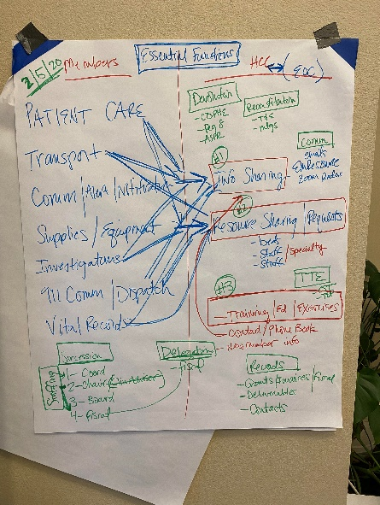
Figure 1: Photo of the NERHCC MEF Discussion (Feb 5, 2020)

February 5, 2020 MEF Discussion
All member identified MEF categories were identified to be primarily supported by information sharing and resource sharing. Those present explained they would look to the healthcare coalition for assistance in coordinating communications and resources needed for patient care/transport. As well, there was discussion regarding following proper chain of command during an EOC activation and how information sharing, and resources requests would be supported by the NERHCC via the local ESF 8 representative and county emergency manager.

Orders of Succession
The following was documented as suggestions for the NERHCC:
- Readiness and Response Coordinator
- Chair
- Clinical Advisor
- Steering Committee/ NERHCC Board
- Fiscal Agent

Communication
It was determined that email, EMResource and Zoom web conferencing were identified as the prioritized modes of communication during a COOP activation for NERHCC, per this group of participants.

Records management
The following were identified as items that require additional discussion and planning to ensure redundancy/ availability:
- Grant Deliverables
- Membership Grant Submissions
- Invoices
- Fiscal Agent Contract
- NERHCC Membership Contact List

Delegation of Authority
It was discussed both Administrative and Emergency authorities would be authorized; the fiscal agent would be looked to for all financial decisions.

Devolution of Control
It was discussed, and the following was suggested for how the NERHCC MEFs would be devolved in the event the NERHCC is unable to perform them:
- CDPHE
- Region 8
- ASPR

Reconstitution
It was discussed, and the following list documents the order in which the non-mission essential functions would be reconstituted following a COOP activation:

- Training and Exercises
- NERHCCMeetings

February 13, 2020- Haxtun, CO

NERHCC Member MEFs | NERHCC MEFs
Staffing | Priority #1: Staffing/ Resources  - Subject Matter Experts (SMEs)  - Inventory
Urgent/ Emergent Patient Care | Priority #2: Communication/ Information Sharing
Elder Care | Training and Exercise
Communication – Cell; 911; Information Technology (IT) | Recovery
Power | Transport
Buildings
Subsistence
Security
Transport/ Transfers

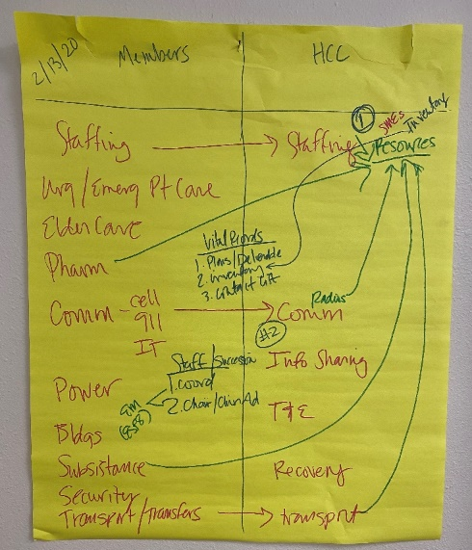
Figure 2: Photo of the NERHCC MEF Discussion (Feb 13, 2020)

February 13, 2020 Discussion
Staffing, Pharmacy, Subsistence, Transport and Communication Radios were the member identified MEFs that were mapped to the NERHCC MEF “Staffing/ Resources”. A larger discussion occurred regarding what resources could be shared during a COOP activation and what sharing staff may look like, which was identified as the most significant resource/ asset for the NERHCC membership and most difficult to coordinate.

Communication was the member identified MEF that was identified for the to the NERHCC MEF “Communication/ Information Sharing”. A similar conversation from the February 5, 2020 Initial COOP Workshop occurred during this workshop involving those present explaining they would look to the healthcare coalition for assistance in coordinating communications and resources needed for patient care/transport.

Orders of Succession
The following was documented as suggestions for the NERHCC:
- Readiness and Response Coordinator
- Chair/ Clinical Advisor
- EM/ ESF8

Records Management
The following were identified as items that require additional discussion and planning to ensure redundancy/ availability:
- Plans/ Grant Deliverables
- Resource Inventory
- NERHCC Membership Contact List

NERHCC Mission Essential Functions (MEF)s
Based on the two COOP Workshop discussions the following have been identified as the NERHCC MEFs:

NERHCC MEFs
Information Sharing
- SMEs
- Inventory
Resource Sharing/ Requests
- Beds
- Staff/ Specialty Staff
- Resources

Appendix 2: NERHCC Business Impact Analysis (BIA) Questions

The following is a Business Impact Analysis Questionnaire template created from the combined feedback from the NERHCC COOP Workshops. This is available for use by any organization within the Northeast Region. Areas shaded in gray are meant to be completed by each organization prior to sending the questionnaire.

- Introduction
(Agency Name) is developing a Continuity of Operations (COOP) plan. This important planning step is meant to ensure (Agency Name) will be able to provide its (customers/patients/clients) with the (services/care) they need and also the safety and wellbeing of all staff when a business interruption occurs.

What is COOP and why should it matter to me?
- Planning Strategy: Continuity of Operations (COOP) helps mitigate and minimize business interruptions.
- Day to Day Operations: Ensures YOU are able to continue working, no matter what.

This Business Impact Analysis (BIA) accomplishes the following:
- Gathers information about the different functions within the hospital.
- Identifies how functions would be impacted during a business interruption.
- Creates a map of the essential functions (which MUST occur) and supporting essential functions (essential functions cannot be maintained without this).

Thank you for your participation and if you have any questions please reach out to (COOP Planning Lead Name) at (Email and/or Phone Number).

- BIA Survey
  - First Name
  - Last Name
  - Phone Number
  - Email
  - Which department do you work for?
    - Best Practice: If possible, get the list of departments from your HR department and provide them as answer choices. This will make the survey easier for the participant and for analyzing the data later.

  - What is your job title?
    - Best Practice: If possible, get the list of job titles from your HR department and provide them as answer choices. This will make the survey easier for the participant and for analyzing the data later.

  - It is important to have three people identified within each department who understand the primary job responsibilities of the department and what is required to continue its operations.

Please provide the position title and name of the persons within your department who understand and are capable of ensuring the primary job responsibilities of the department:

Example from Survey Monkey:
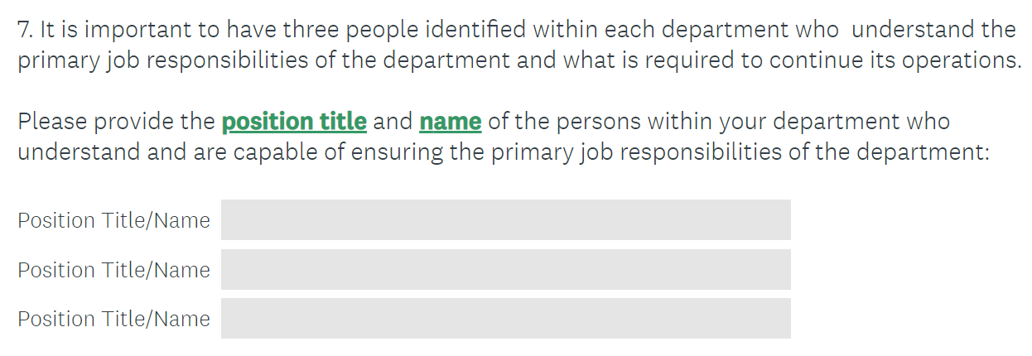

  - What are your department's hours of operation?

Example from Survey Monkey:
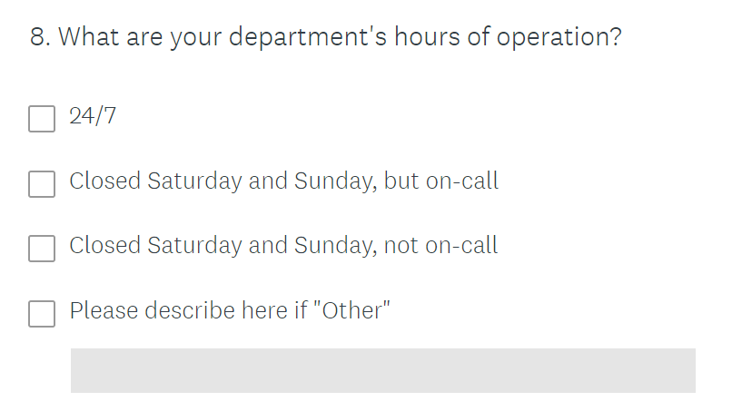

  - What are the Essential Functions your department provides?

Example of an Essential Function:
(Insert Essential Function Example that is applicable to your facility/agency)

Essential Functions are generally broad statements that may have several different methods of accomplishing them. When thinking about your department's essential functions, consider the following:

"X" (insert essential function) is what our department provides in the (facility/agency) that no other department is able and/or capable of providing (i.e. specialized equipment, specialized staff, the physical environment).

Best Practice: Limit the number of available spaces to 3 to 5; if you provide too many text boxes it will be difficult to capture what is truly essential versus normal day to day operational tasks.

Example from Survey Monkey:
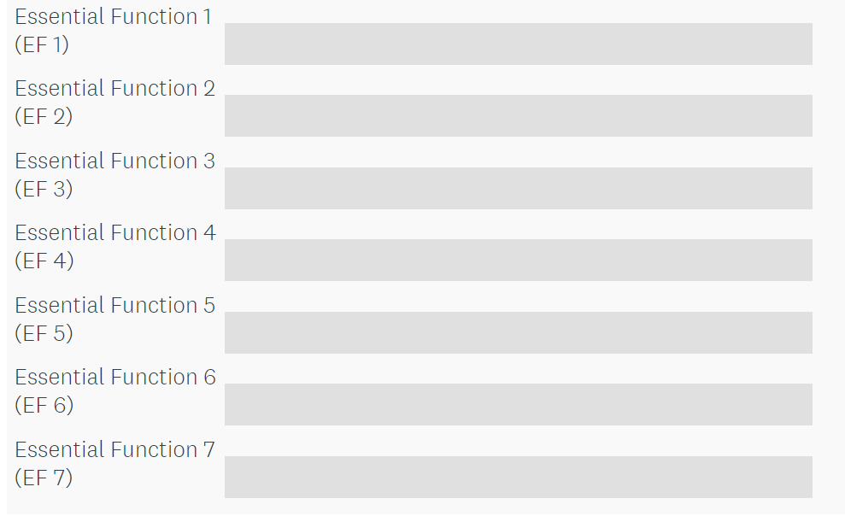

  - Based on the previously identified Essential Functions, please answer the following:
    - Would (customer/ client/ patient) safety be impacted without this essential function?
    - Would employee safety be impacted without this essential function?
    - Would the environment still be able to support (customer/ client/ patient) services without this essential function?

  - What are the Supporting Essential Activities (SEA) of your department?

Examples of a Supporting Essential Activity:
(Insert Supporting Essential Activity Example that is applicable to your facility/agency)

When thinking about your department's supporting essential activities consider the following:
If "X" (insert support essential activity) supporting essential activity did not occur, "X" essential function would not be possible.

  - Based on the previously identified Supporting Essential Activities, please answer the following:
    - Would (customer/ client/ patient) safety be impacted without this Supporting Essential Activity?
    - Would employee safety be impacted without this Supporting Essential Activity?
    - Would the environment still be able to support (customer/ client/ patient) services without this Supporting Essential Activity?
  - Please provide the following information about the IT applications your department must have in order for essential functions and supporting essential activities to occur:
    - Maximum Tolerable Downtime (MTD) i.e. how long can you function without this application? Choose from these options:
        - 0
        - 1-12 hours
        - 13-24 hours
        - 25-48 hours
        - 49-72 hours
        - Greater than 72 hours
    - Best Practice: Work with your IT Department to get a list of all actively licensed applications and provide within the survey. This ensure more accuracy and helps your IT department with their disaster recovery planning.

  - What hard copy documents does your department need in order for your essential functions and supporting essential activities?

  - What specialty equipment is required in order for your departments essential functions and supporting essential activities to occur? Please assume that all basic office equipment will be provided i.e. copier, fax, etc.

  - What modes of communication does your department rely on?
    - Best Practice: Provide answer options and allow for a comment at the end in case they have a unique communication modality.
    - Examples:
      - Office Phone
      - Cell Phone
      - Work Cell Phone
      - Personal Cell Phone
      - Fax
      - Email
      - Pager
      - Two-Way Radio(s)
      - 800 MHz Radio
      - 400 MHz Radio
      - Emergency Notification System

  - What type of staff would your department require in order to perform its essential functions and supporting essential activities? Please specify the POSITION TITLE and then the NUMBER your department would need.

  - Please provide any additional comments, concerns or suggestions regarding Continuity of Operations (COOP) Planning for your department.

