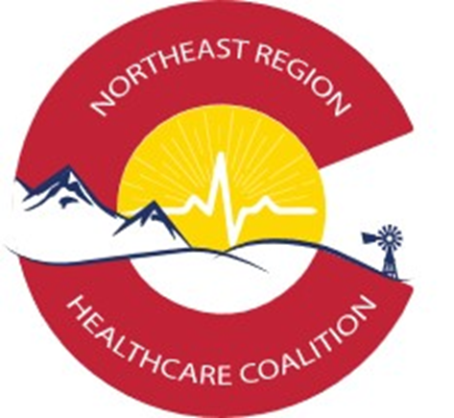

Inclusion of Health and Medical Volunteers in Emergency Response

Northeast Regional Healthcare Coalition Report
2019 Deliverable #25

Table of Contents
1. Report Summary and Background 3
2. Volunteer Usage 3
2.1 Successes and Current Usage Examples 3
2.2 Challenges and Identified Gaps 3
3. Future Recommendations and Initiatives 4

1. Report Summary and Background
This report on the usage and inclusion of volunteers in health and medical emergency incidents is being provided to the Colorado Department of Public Health and Environment as a 2019 Healthcare Coalition Workplan, deliverable #25. Northeast Regional Healthcare Coalition members were surveyed on their use of volunteers to provide information on the current utilization and functionality of health and medical volunteers during incident response. Due to the pandemic response to COVID-19, the use of volunteer resources to respond to the pandemic event was able to be accurately measured with information gathered during the NERHCC After Action data gathering process.
Findings indicate NERHCC members do not currently utilize health and medical volunteers widely. The identification, on boarding, training, engagement, and management of medical and specialty volunteers for use in emergencies and in response to health-based incidents seem to be the primary challenges to the effective use of volunteers. Some hospital systems utilize volunteers effectively on a day to day basis, but those resources are not medically trained and would have limited capabilities during health or emergency incidents. Medically trained volunteers must maintain certifications, be trained on hospital or entity policies and procedures, be provided access to the building and to charting systems and are normally maintained locally or within the agency as opposed to the regional coalition level.

2. Health and Medical Volunteer Usage

2.1 Successes and Current Usage Examples
Based on the NERHCC AAR survey responses, 11% of current NERHCC members utilized volunteers during the response to the COVID 19 pandemic. Of those reporting the use of volunteers, the following comments were shared directly about their use for health and medical incident response:
- We normally use volunteers for our agency, so they were used in response
- We used volunteers but cannot specify usage for this report
Many jurisdictions do not maintain volunteer databases and do not specifically track health and medical volunteers for availability or deploy-ability on a routine basis but were able to effectively engage the community in the response efforts and identified people available to volunteer within the communities. Most hospitals maintain volunteers on a routine basis, but these volunteers are not necessarily medically trained or have medical and health expertise. If they did, it would be expected they would serve in their day to day health role during an emergency instead of being available to support a health and medical response as a volunteer.
Health and Medical volunteers may also be associated with various volunteer organizations, both locally and at State and Federal levels. Their ability to volunteer would depend on what was happening (is the incident local, State, or Nationwide?) which reduces the total number of health and medically trained volunteers available at any given time.

2.2 Challenges and Identified Gaps
Based on the NERHCC AAR survey respondents, 89% of current NERHCC members did not utilize volunteers during the response to the COVID 19 pandemic which led to a community surge of patients.
Common challenges reported regarding the use of volunteers have been collected as follows:
- Difficult to identify trained volunteers who could support Health and Medical operations
- Difficult to credential and maintain certification on volunteers if it is not handled internally to an agency and checked regularly – this makes specifically health and medical volunteers an even more difficult asset to manage
- Difficult to identify volunteers who will be available to respond during an incident requiring a specific health and medical response
Community response to health and medical incidents will be primarily managed through hospitals and community healthcare providers with support from the ESF 8 system and supporting agencies. These agencies may maintain lists of volunteers to support more routine emergency operations (shelter management, EOC support, logistics, general volunteer opportunities) but do not routinely maintain lists of available volunteers who have health and medical specialties. Due to liability, training, regulatory and certification requirements the use of health and medical volunteers within these agencies would not normally occur.
These volunteers might be used in the community to support this type of response but would normally be provided as part of a State or Federally managed team based on the difficulty and complexity of medical volunteer management. Disaster Medical Assistance Teams (DMAT) and Disaster Mortuary Response Teams (DMORT) teams are the most likely resources which would be deployed in these situations to handle health and medical specific response operations to support the healthcare system DMAT and DMORT teams are federally funded and paid resources. Just in time recruitment of volunteers would be another available option for obtaining health and medical volunteers during emergencies, but the need to establish rapid credentialing and qualification procedures which would be standardized across Coalition partners to ensure the ability to share volunteers.

3. Future Recommendations and Initiatives
In larger communities within the NE Region it might be possible to maintain lists of volunteers, to form and utilize volunteer groups and to increase capacity. However, there many challenges in managing volunteers that are inhibiting factor when volunteers are considered to support response to surge incidents in the community. If CDPHE could provide the recruitment and management function for these groups, their use might be increased. It is also important to remember that the same people who volunteer during a surge incident are usually people who work full time jobs during emergencies and so the actual available volunteer workforce may be significantly less during incident response and should be a planning factor for consideration.
A Volunteer Management Annex will be a required deliverable for the 2020-2021 HCC deliverables. This plan will include information on the following items:
- Identify situations that would require supplemental staffing in hospitals and leverage existing hospitals and health system staff sharing agreements and resources, to include volunteers.
- Develop rapid credentialing verification processes to facilitate emergency response.
- Identify and address volunteer liability, licensure, workers comp, scope of practice, and third-party reimbursement issues that may deter volunteer use.
- Leverage existing programs (ESAR-VHP, Medical Reserve Corps) to identify and staff health care roles during acute care medical surge response training, drills, and exercises
- Determine how to integrate volunteers into exercises, drills, and training within the Volunteer Management Annex.

In the NE Region, a process to share staff and coordinate them among HCC partner agencies may be a focus of work over the coming years outside of the plan annex. The volunteer management annex will be developed and updated on an ongoing basis and will also refer to the CDPHE volunteer management plan to ensure it directly coordinates with Statewide volunteer management and usage efforts.

There should also be a process established by the NERHCC to allow staff from one healthcare facility within the Region to work at other facilities in the region through the development and approval of routine cross training, credential sharing and formalized staff share programs. Plans to develop this level of volunteer and staff sharing do not currently exist and would take a significant amount of coordination and effort to ensure functionality.

